**Project 3 Part 4 (randomized approach average O(n))**

Name: ____Joshua Hsueh________________________ Period: __3_______________

Date: ____12/10/2020____________________

Is your lab name l034?(lowercase L followed by digits 034) ____Yes_______

Did you created a class to store a point? ___Yes_______

Did you use a vector to store the points you read? ___Yes________

Does your main contain only 2 calls of: part3() and part4() (NO part1/2!!)? ______Yes___

(in main you may also have the part to display results for the 2 methods and them also in the txt file)

Did you use an unordered_map for your dictionary? _____Yes______

Did you implement the Knuth algorithm to randomize the points? _____Yes______

1. **Paste here a clear picture of the graph that compares the running times of the “full recursive” algorithm and “randomized” algorithm versus number of points. (use 2 different colors for the 2 graphs, colors that can be visible even if you print in black and white). Each point on this graph should be an average of several runs for that size:**

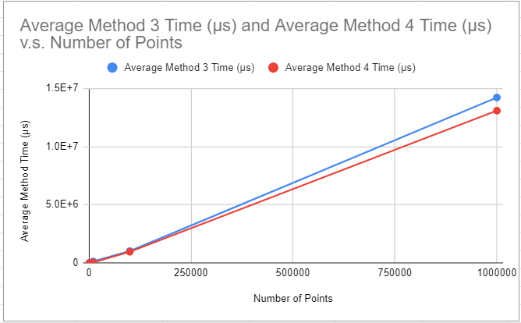

1. **Paste here the content of the results.txt when you run your lab on the content of the file points10k.txt and points100k.dat**

**For 10k:**

**Part 3: (0.49999999999999883426582414,0.50000000000000033306690739) , (0.49999999999999888977697537,0.50000000000000033306690739)**

**Distance: 0.00000000000000005551115123**

**Time: 118597.0 microseconds**

**Part 4: (0.50000000000000122124532709,0.49999999999999983346654631) , (0.50000000000000122124532709,0.49999999999999977795539507)**

**Distance: 0.00000000000000005551115123**

**Time: 38666.0 microseconds**

**For 100k:**

**Part 3: (0.49999999999973127051688948,0.49999999999889993551605016) , (0.49999999999975941467056373,0.49999999999890892832254963)**

**Distance: 0.00000000000002954596342610**

**Time: 999952.0 microseconds**

**Part 4: (0.49999999999973127051688948,0.49999999999889993551605016) , (0.49999999999975941467056373,0.49999999999890892832254963)**

**Distance: 0.00000000000002954596342610**

**Time: 839707.0 microseconds**